Business Intelligence Life Cycle

1. Understanding the requirements and delivering the valuable business output
2. Act in accordance with the proven Data Warehouse Lifecycle.
3. Building and delivering progressively within the organization’s data framework
4. Designing flexible, useful and high-performance datasets.
5. Providing a complete business solution via reports, query tools, documentation.

All the BI projects require design, development and testing as a part of the BI lifecycle. The lifecycle gives them the overall perspective including technical and managerial for the end-to-end considerations in deploying the complex data warehousing systems.

Business Intelligence Lifecycle process:

[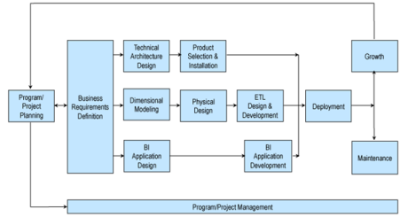](https://intellipaat.com/wp-content/uploads/2016/01/business-intelligence-lifecycle-process.png)

**Project Planning**

The first phase of the BI lifecycle includes **Planning** of the business Project or Program. This makes sure that the business people have a proper checklist and proper planning considerations to design complicated systems in [data warehousing](https://intellipaat.com/blog/tutorial/data-warehouse-tutorial/data-warehousing-terminologies/).

Project Planning decides and distributes the roles and responsibilities of all the executives involved in a particular project. The working executives then designs a detailed project plan before performing any relevant action.

Further, all the business requirements for designing and developing the project are evaluated and accessed before starting to work in real-time.

The second phase is **Business Requirements Definition**, which is a detailed project plan where key team members of the projects should develop proper estimates for the tasks. The unique characteristics of the project like cross-functional, high visibility and iterative- should be kept in mind. Further, the team members should identify the data problems well in time.

After that, the experts need to define the **business process dimensional model**, which includes the primary dimensional modelling concepts, changing dimensions, the modelling process and data profiling and stewardship. The business process dimensional model is also referred to as star schema which is an easy-to-understand and better performance relational model having entities/objects/dimensions with all attributes. There is one active row per occurrence of the object, and the dimensions are open to any further changes.

[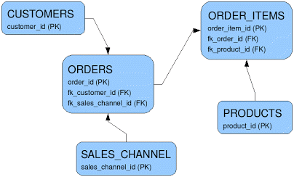](https://intellipaat.com/wp-content/uploads/2016/01/normalized-table.png)

**BI Application design** refers to developing standard templates and navigation. The **BI Application development** includes standard and flexible reporting and complex analysis and the current business review.

The templates and reports are designed such that they allow end-to-end user navigation. The application development phase also covers data validation, performance tuning, maintenance and enhancement resources and data quality check.

As per the names, after all the design and development, Security, Deployment (documentation) and Maintenance (system and user support) tasks must be performed.

Growth refers to the ongoing/iterative process for business. It focuses on revisiting opportunities and setting the next priorities.

Besides, building additional dimensions, successful delivery of BI applications and rollout and repeat are the other processes included in the growth phase.

# //Enterprise Business Intelligence and Information Workers

<https://www.youtube.com/watch?v=jLHIlHFlTCU//>

################################################################

Framework Elements / Architecture

A Business Intelligence Framework is a framework that seamlessly connects the various elements of a business: organizational roles, [KPIs,](https://www.passionned.com/strategy/pm/kpi/) authorization, and [visualization](https://www.passionned.com/bi/data-visualization/).

This helps you implement Business Intelligence plans both easier and faster.

There are many important factors, but the key ones include:

* **Backlog of business requests:** IT department is under a lot of pressure to fulfil the report requests from various business users.
* **Need for self-service BI:**Business users are stuck as they need to depend on IT for even minor pieces of information. This hinders their decision-making process and forms a bottleneck for smooth operation.
* **Messed up IT system:**Silos of data, different data formats, disparate data and applications – these will form a complex IT system, building a justified case for a stronger BI infrastructure.
* **Cost:**Cost of maintaining information silos and feeding to huge number of IT resources for even small sets of data is detrimental to an organization.

These factors push the organizations to build a business intelligence architecture that will seek to help them make better decisions.

A solid architecture will help in structuring the process of improving business intelligence and helps implement the Business Intelligence strategy in a very cost-effective way.

The key elements of a business intelligence architecture are:

* Source systems
* ETL process
* Data modelling
* Data warehouse
* Enterprise information management (EIM)
* Appliance systems
* Tools and technologies

**Source Systems – Transaction Processing Systems**

This is the starting point for any BI initiative. Organization data is first created in these databases.

Operational systems (OLTP) form the bulk of the data needed for the data warehousing. In addition to that, source systems may also include data from secondary sources such as market data, benchmarking data etc.

Business Intelligence architecture should address all these various data sources which are of different formats and standards.

**ETL Process**

In an ETL process data is extracted from the operational systems and loaded into a data warehouse. ETL, which stands for Extract Transform Load, is usually done using custom solutions available in the market.

IBM WebSphere Data Stage, Oracle Data Integrator, Ab Initio, and Microsoft Integration Services are examples of such tools.

**Data Modelling3**

Data modelling will help to address what exactly is needed from data sources, the format of the data, and how it will be related to other data elements

Data modelling will help to organize the data and therefore will minimize cost of storage replication, and effort needed to build a data warehouse.

**Data Warehouse**

Warehouse will have data extracted from various operational systems, transformed to make the data consistent, and loaded for analysis. A data warehouse will help in achieving cross-functional analysis, summarized data, and maintaining one version of the truth across the enterprise.

**Enterprise Information Management (EIM)**

EIM is another BI jargon which may stump some beginners. The term usually refers to ETL tools, data modelling tools, data quality, data profiling, metadata management, and master data management.

**BI Hardware**

It is important to make decisions on the hardware requirements to maintain a high performance and scalable BI system.

Apart from server configurations, we have data warehouse appliances to combine the server, the database, and the data storage into one system.

Netezza and DATA_llegro are some well-known appliances in the market.

**Tools and Technologies**

Another important component of business intelligence architecture is what tools and technologies to implement. It is not just the front-end UI tools, but the tools used for EIM as well.

There are cloud solutions, SaaS model, many full-fledged BI solutions (such as MSBI, Oracle BI suites, MicroStrategy and more) to choose from.

BI framework should have guidelines to make decisions on what is required for the organization.

BI Strategy

[https://www.tableau.com/learn/articles/business-intelligence/successful strategy](https://www.tableau.com/learn/articles/business-intelligence/successful%20strategy).